**CSS Assignment**

1. What are the benefits of using CSS?

Ans: - The benefits of using CSS Are for better presentation of webpage the Separation of content and giving each single content a different style. Consistent styling of multiple pages using a single extremal CSS file. Responsive design using of css We can make responsive web designs that adapt to different screen sizes and devices. Animation We give animation on webpage transitions without using JavaScript.

1. What are the disadvantages of CSS?

Ans: - The CSS might have a steep learning curve. Understanding the box model, positioning, and the cascade can be challenging. using of css hard to maintain large style sheets. The specificity of styles and the cascading nature of C Large and complex stylesheets can impact page loading times and overall performance.

1. What is the difference between CSS2 and CSS3?

Ans: - CSS2 and CSS3 have introduced many new features and enhancements, making web design even more exciting and dynamic. Some of the key differences between these versions include improved selectors, advanced layout options, and new visual effects like gradients, animations, and transformations. CSS3 is the latest version, hence it supports responsive .CSS2 not provide grid system but CSS3 comes with the grid system and template layout module.

1. Name a few CSS style components

Ans: - CSS Style components

*{marging:0;

Padding:0;

box-sizing: border-box;

}

.main {background-colour: white;

padding: 15px;

colour: blue;

text-align: centre;

font-size: 14px;

}

1. What do you understand by CSS opacity?

Ans: - CSS opacity refers to the transparency level of an element, allowing you to control how much the content inside an element is visible. It is a property that can be applied to various HTML elements using CSS. The opacity property takes a value between 0 and 1. Opacity using for image, text and background.

1. How can the background colour of an element be changed?

Ans: - To change the background color of an element using CSS, you can use the background-color property. Here's an

ex: <style>

.h1 {

background-color: lightblue;

}

div {

background-color: blue;

}

p {

background-color: yellow;

}

</style>

1. How can image repetition of the backup be controlled?

Ans: - The image repetition of the backup be controlled using for ‘background-repeat’

Background-image should have repeated both horizontally and vertically. Here are the example.

EX: <style>

. image {

background-image: url ("Photo-g.png");

background-repeat: no-repeat;

background-repeat: repeat-x;

background-repeat: repeat-y;

}

</style>

1. What is the use of the background-position property?

Ans: - The background-position property in CSS is used to set the starting position of a background image within its containing element. It allows you to control where the background image is placed in relation to the element's box. You can give position “left, right, center “and “top, center, bottom.

Ex: <style>

body {

background-image: url("image-of.png");

background-repeat: no-repeat;

background-position: right top;

background-position: left bottom;

background-position: center bottom;

}

</style>

1. Which property controls the image scroll in the background?

Ans:- The property that controls the background image scroll behaviour is the background-attachment property in CSS. The background-attachment property determines whether the background image is fixed within the viewport or scrolls along with the content. Using

“background-attachment: scroll;” for image scroll in background.

Ex: - <style>

. main {

background-image: url ("my photo.png");

background-repeat: no-repeat;

background-attachment: scroll;

}

</style>

1. Why should background and color be used as separate properties?

Ans: - background and color as separate properties because background property can be used to set both the background color and background image and color using for text color and and content color

Ex: - <style>

div {

background-color: skyblue;

background-image: url('background-image.jpg');

color: white;

background-repeat: repeat;

}

</style>

1. How to center block elements using CSS1?

Ans:- The center block elements give margin-left :auto;, margin-right: auto; , text-align:center;

Using to give center block element in CSS1.

Ex:- <style>

img {

display: block;

margin-left: auto;

margin-right: auto;

text-align: center;

}

</style>

1. How to maintain the CSS specifications?

Ans: - Maintaining CSS specifications involves keeping your stylesheets organized, Use meaningful class and ID names to make your stylesheets more readable and maintainable. Add comments to explain the purpose of specific sections or styles within your CSS. Use comments to provide information about the purpose of certain classes, IDs, or styles. Design with responsiveness in mind to ensure your styles adapt well to different screen sizes and devices.

1. What are the ways to integrate CSS as a web page?

Ans:- There are three ways to integrate css as a web page.

External CSS: - External styles involve creating a separate CSS file and linking it to the HTML document using the <link> tag. This method using you can change of entire websites pages by single CSS sheet.

EX:-

HTML FILE

<html>

<head>

<link rel="stylesheet" href="mystyle.css">

</head>

<body>

<h1>I LOVE CSS</h1>

<p>This is a CSS. </p>

</body>

</html>

CSS FILE

p{  
background-color: light blue;}  
  
h1 {  
  color: navy;  
  margin-left: 20px;  
}

Inline CSS: - Inline styles are applied directly to individual HTML elements using the <style> attribute. This method is useful for quick styling but is generally not recommended for larger projects due to its lack of separation of concerns.

Ex:- <html>

<body>

<h1 style="color: blue; text-align: center;">My World</h1>

<p style="color: red;">This is Nice</p>

</body>

</html>

Internal CSS: - Internal styles are placed within the HTML document, typically within the <style> tag in the <head> section. An internal style sheet may be used if one single HTML page has a unique style.

Ex:- <html>

<head>

<style>

body {

background-color: linen;

}

h1 {

color: maroon;

margin-left: 40px;

}

</style>

</head>

<body>

<h1>heading</h1>

<p>This is a CSS. </p>

</body>

</html>

1. What is embedded style sheets?

Ans:- Embedded style sheets, also known as internal style sheets, involve placing CSS directly within the HTML document. The styles are specified within the <style> element, typically in the <head> section of the HTML document. This method allows you to define styles that apply specifically to the elements within that HTML document.

Ex:- <html>

<head>

<style>

body {

background-color: linen;

}

h1 {

color: maroon;

margin-left: 40px;

}

</style>

</head>

<body>

<h1>heading</h1>

<p>This is a CSS. </p>

</body>

</html>

1. What are the external style sheets?

Ans:- External styles involve creating a separate CSS file and linking it to the HTML document using the <link> tag. This method using you can change of entire websites pages by single CSS sheet.

EX:-

HTML FILE

<html>

<head>

<link rel="stylesheet" href="mystyle.css">

</head>

<body>

<h1>I LOVE CSS</h1>

<p>This is a CSS. </p>

</body>

</html>

CSS FILE

p {

background-color: light blue;}

h1 {

color: navy;

Margin-left: 20px;

}

1. What are the advantages and disadvantages of using external style sheets?

Ans: - The advantages and disadvantages of using external style sheets is as under.

Advantage: - External style sheets promote modularity by allowing you to reuse styles across multiple pages. This is especially useful for maintaining a consistent design throughout a website.

There is no restriction to the number of web pages that can use the external style sheet.

External style sheets ensure a consistent look and feel across all pages that reference the same stylesheet.

Disadvantage: - Each external stylesheet results in an additional HTTP request, which can slightly impact page load times. This is a consideration for performance optimization.

For very small projects or single-page applications, the overhead of creating and managing an external stylesheet might be unnecessary.

In such cases, inline or internal styles may be more straightforward.

1. What is the meaning of the CSS selector?

Ans: - A CSS selector is a pattern or a set of rules that define how styles should be applied to HTML elements on a web page. Selectors target specific elements based on their type, attributes, class, ID or their relationship with other elements in the HTML document. HTML elements should be selected to have the CSS property values inside the rule applied to them

Element selector, Id Selector, Attribute Selector, universal selector etc.

1. What are the media types allowed by CSS?

Ans: - CSS allows you to specify different styles for different media scree As per Available As per pic.

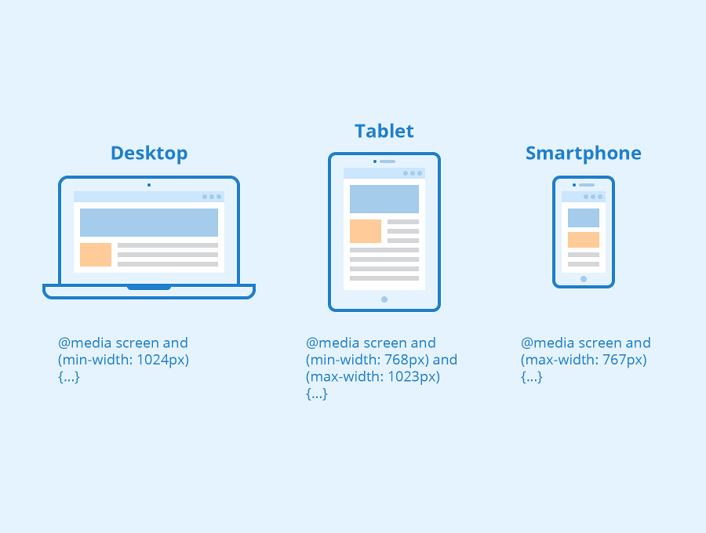

1. What is the rule set?

Ans: -  A selector list and an associated declarations block, together, are called a ruleset, or often a rule It is the fundamental structure used to define styles for HTML elements.

The rule set specifies which elements on an HTML document should be styled and how those styles should be applied.

Selector: Identifies the HTML element or elements to which the styles should be applied. Selectors can be based on the element type, class, ID, or other criteria

Declaration Block: Enclosed within curly braces {} and contains one or more property-value pairs separated by semicolons. Each property-value pair defines a specific style attribute for the selected elements.

Property: Specifies the CSS property (e.g., color, font-size, margin) that you want to set.

Value: Specifies the value of the property.

1. Create Layouts

